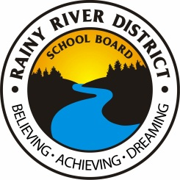
Application of Interest

For Facility Partnership

Potential facility partners are required to submit this form to the Communications/Community Outreach Officer of the Rainy River District School Board to be considered as an approved facility partner. Review of all applications will be done by the RRDSB Administrative Council. Results of the review process will be provided by mail to applicants.

Name of Organization:
Full Address:
Contact Name:
Position:
Contact Information: |  | Phone:
 |  | Cell:
 |  | E-mail:
Location Desired (name of school, as per information on website)

Please provide a description of your organization and its goals.

How would a facility partnership between the Board and your organization provide a benefit to the students at the school and/or to the Board?

Please provide a description of the service or services to be offered in the facility.

Please indicate your facility needs including size and type of space, unique service requirements (if any), parking/green space requirements, etc.

What would your hours of operation be?

How many staff/visitors/clients would you estimate to access your operations in a day?

Are there any specific timelines required (e.g., start/end dates) to this partnership?

Please provide any other information that you feel may be pertinent to this application.

Submitted by: |  |  |  | Date:
 | Signature
Print Name: |  |  |  | Title:

For more information, please contact:

Darlene Madill
Communications/Community Outreach Officer
Rainy River District School Board
dmadill@mail.rrdsb.com
(807) 274-9855 ext. 4989
Toll free 1-800-214-1753

